PETITION FOR RELIEF FROM SEIZURE
Case Number: 2011 2501 000533
Date: 9/27/2011

Dear Ms. Gomez,
I am writing in an effort to gain relief from the forfeiture of our property which was seized on August 26, 2011 at the Port of San Diego. We wish to have the property released to us as described within this petition and within the attached Election of Proceedings form.
Unfortunately, information that would have likely saved us all the hassle of having the products seized was not passed along by our customs agent. This information includes documentation on the approval of the Roachclips® from the U.S. Patent and Trademark office for use in commerce within the United States (details within).
It is our hope that after reviewing this petition you will agree with the conclusion that this product is not paraphernalia as they are not intended for any illegal use and not designed as such. The Roachclips® were approved by the USPTO (product #3036190) as they are simply “toy roaches with a clip attached so they may be worn as a pin or used as prank to scare a friend.” They are novelty items sold legally in retail shops and used as a promotional item for our website Roachclip.com, which promotes nothing illegal. Additionally, the Roachclips® have already been approved by the federal government for use in commerce and therefore should not have been seized.
We appreciate your consideration on the matter as it is quite significant for our small business to have our product released. We have several convenience stores and gas stations who wish to purchase our product and without the ability to import them into the country we would suffer considerable loss including the large expense incurred to manufacture them.
Thanks again for your time and assistance with the administrative process to have our property released. Please do not hesitate to let me know if I can answer any questions or supply any additional information.
Sincerely,

9/27/2011
Derek Zimmerman
Banyan Enterprises, LLC
d.b.a. Roachclip.com
4122 Utah St.
San Diego, CA
derek@roachclip.com
530.249.2126

REASON PROVIDED TO US FOR SEIZURE:

- “The property was seized under the provisions of 19 USC 1595a(c) with underlying violation of 21 USC 863, which prohibits/restricts the importation of 20,000 ea Drug Paraphernalia (Roach Clip).”

SUMMARY OF OUR PETITION FOR RETURN OF PROPERTY:

1. Granted U.S. Trademark
Summary: The product was previously reviewed and approved by an examining attorney of the U.S. Patent and Trademark Office and granted an official United States trademark. (details on pages 4-7)
2. Products Are Not Paraphernalia

Summary: The products that were seized are NOT paraphernalia as defined within §21 USC 863(d) and further described in §21 USC 863(e) or §21 USC 863(d)(5) (details on pages 8-10)
3. Wrongful Seizure
Summary: The seized property does not violate any of the terms as described within
§19 USC 1595a(c) nor is it contraband as defined within Section 80302 (details on pages 10-12)
4. Product Approved for Commerce

Summary: Roachclips® use in commerce was verified by statement provided to the USPTO per § 2.33 of federal Rules of Practice (details on pages 12-13)
5. Exempt as per Federal Office

Summary: While the seized products should not be considered paraphernalia, even if they were incorrectly deemed as such they would still be exempt as defined by
§21 USC 863(f) and supported by USPTO Federal Statute § 2.69 (details on pages 13-14)

1. Granted U.S. Trademark
1A. Registered Trademark Information (U.S. Patent and Trademark Office)
1B. Product Images Provided to USPTO (upon request of examining attorney)
1C. Copy of Certificate of Approval for Roachclips (U.S. seal and approval letter)

1A. Registered Trademark Information (U.S. Patent and Trademark Office)
Below is information pulled from the U.S. government website in regard to the LIVE trademark for the Roachclip® product. The Registered Trademark (®) was issued to my business partner Matthew Leitz.

SOURCE: uspto.gov as of 9/28/2011
Registered Trade Mark: ROACHCLIP
Goods and Services IC 028. US 022 023 038 050. G & S: Toy roach with a clip attached so it may be worn as a pin or used as prank to scare a friend. FIRST USE: 20030607.
FIRST USE IN COMMERCE: 20030607
Serial Number 76462202 Filing Date October 28, 2002
Registration Number 3036190
Registration Date December 27, 2005
Owner (REGISTRANT) Leitz, Matthew A. INDIVIDUAL UNITED STATES 3402 Noreen Dr. Columbus OHIO 43221
Type of Mark TRADEMARK
Register PRINCIPAL
Live/Dead Indicator LIVE

1B. Product Images Provided to USPTO (upon request of examining attorney)
When being reviewed by the U.S. examining attorney for approval we were asked to provide product and packaging images. Our product design has remained completely unchanged from the design which was approved by the USPTO (simply a toy cockroach with a clip attached).
Additionally, you can view our Roachclip® packaging design below. While the packaging has become a little more modern over the years, the message on the box is virtually unchanged since approval.

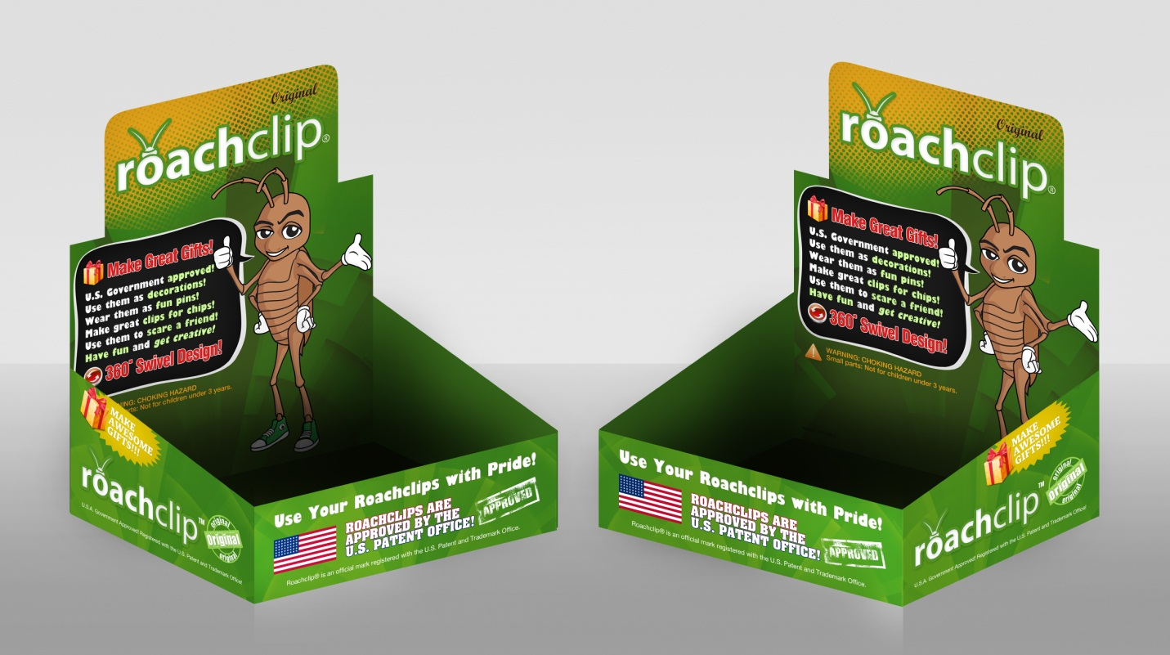

1C. Copy of Certificate of Approval for Roachclips® (U.S. seal and approval letter)
Below is a copy of the seal of approval from the United States Trademark Office as well as the approval letter sent by U.S. examining attorney Linda Mickleburgh. (see next pages)

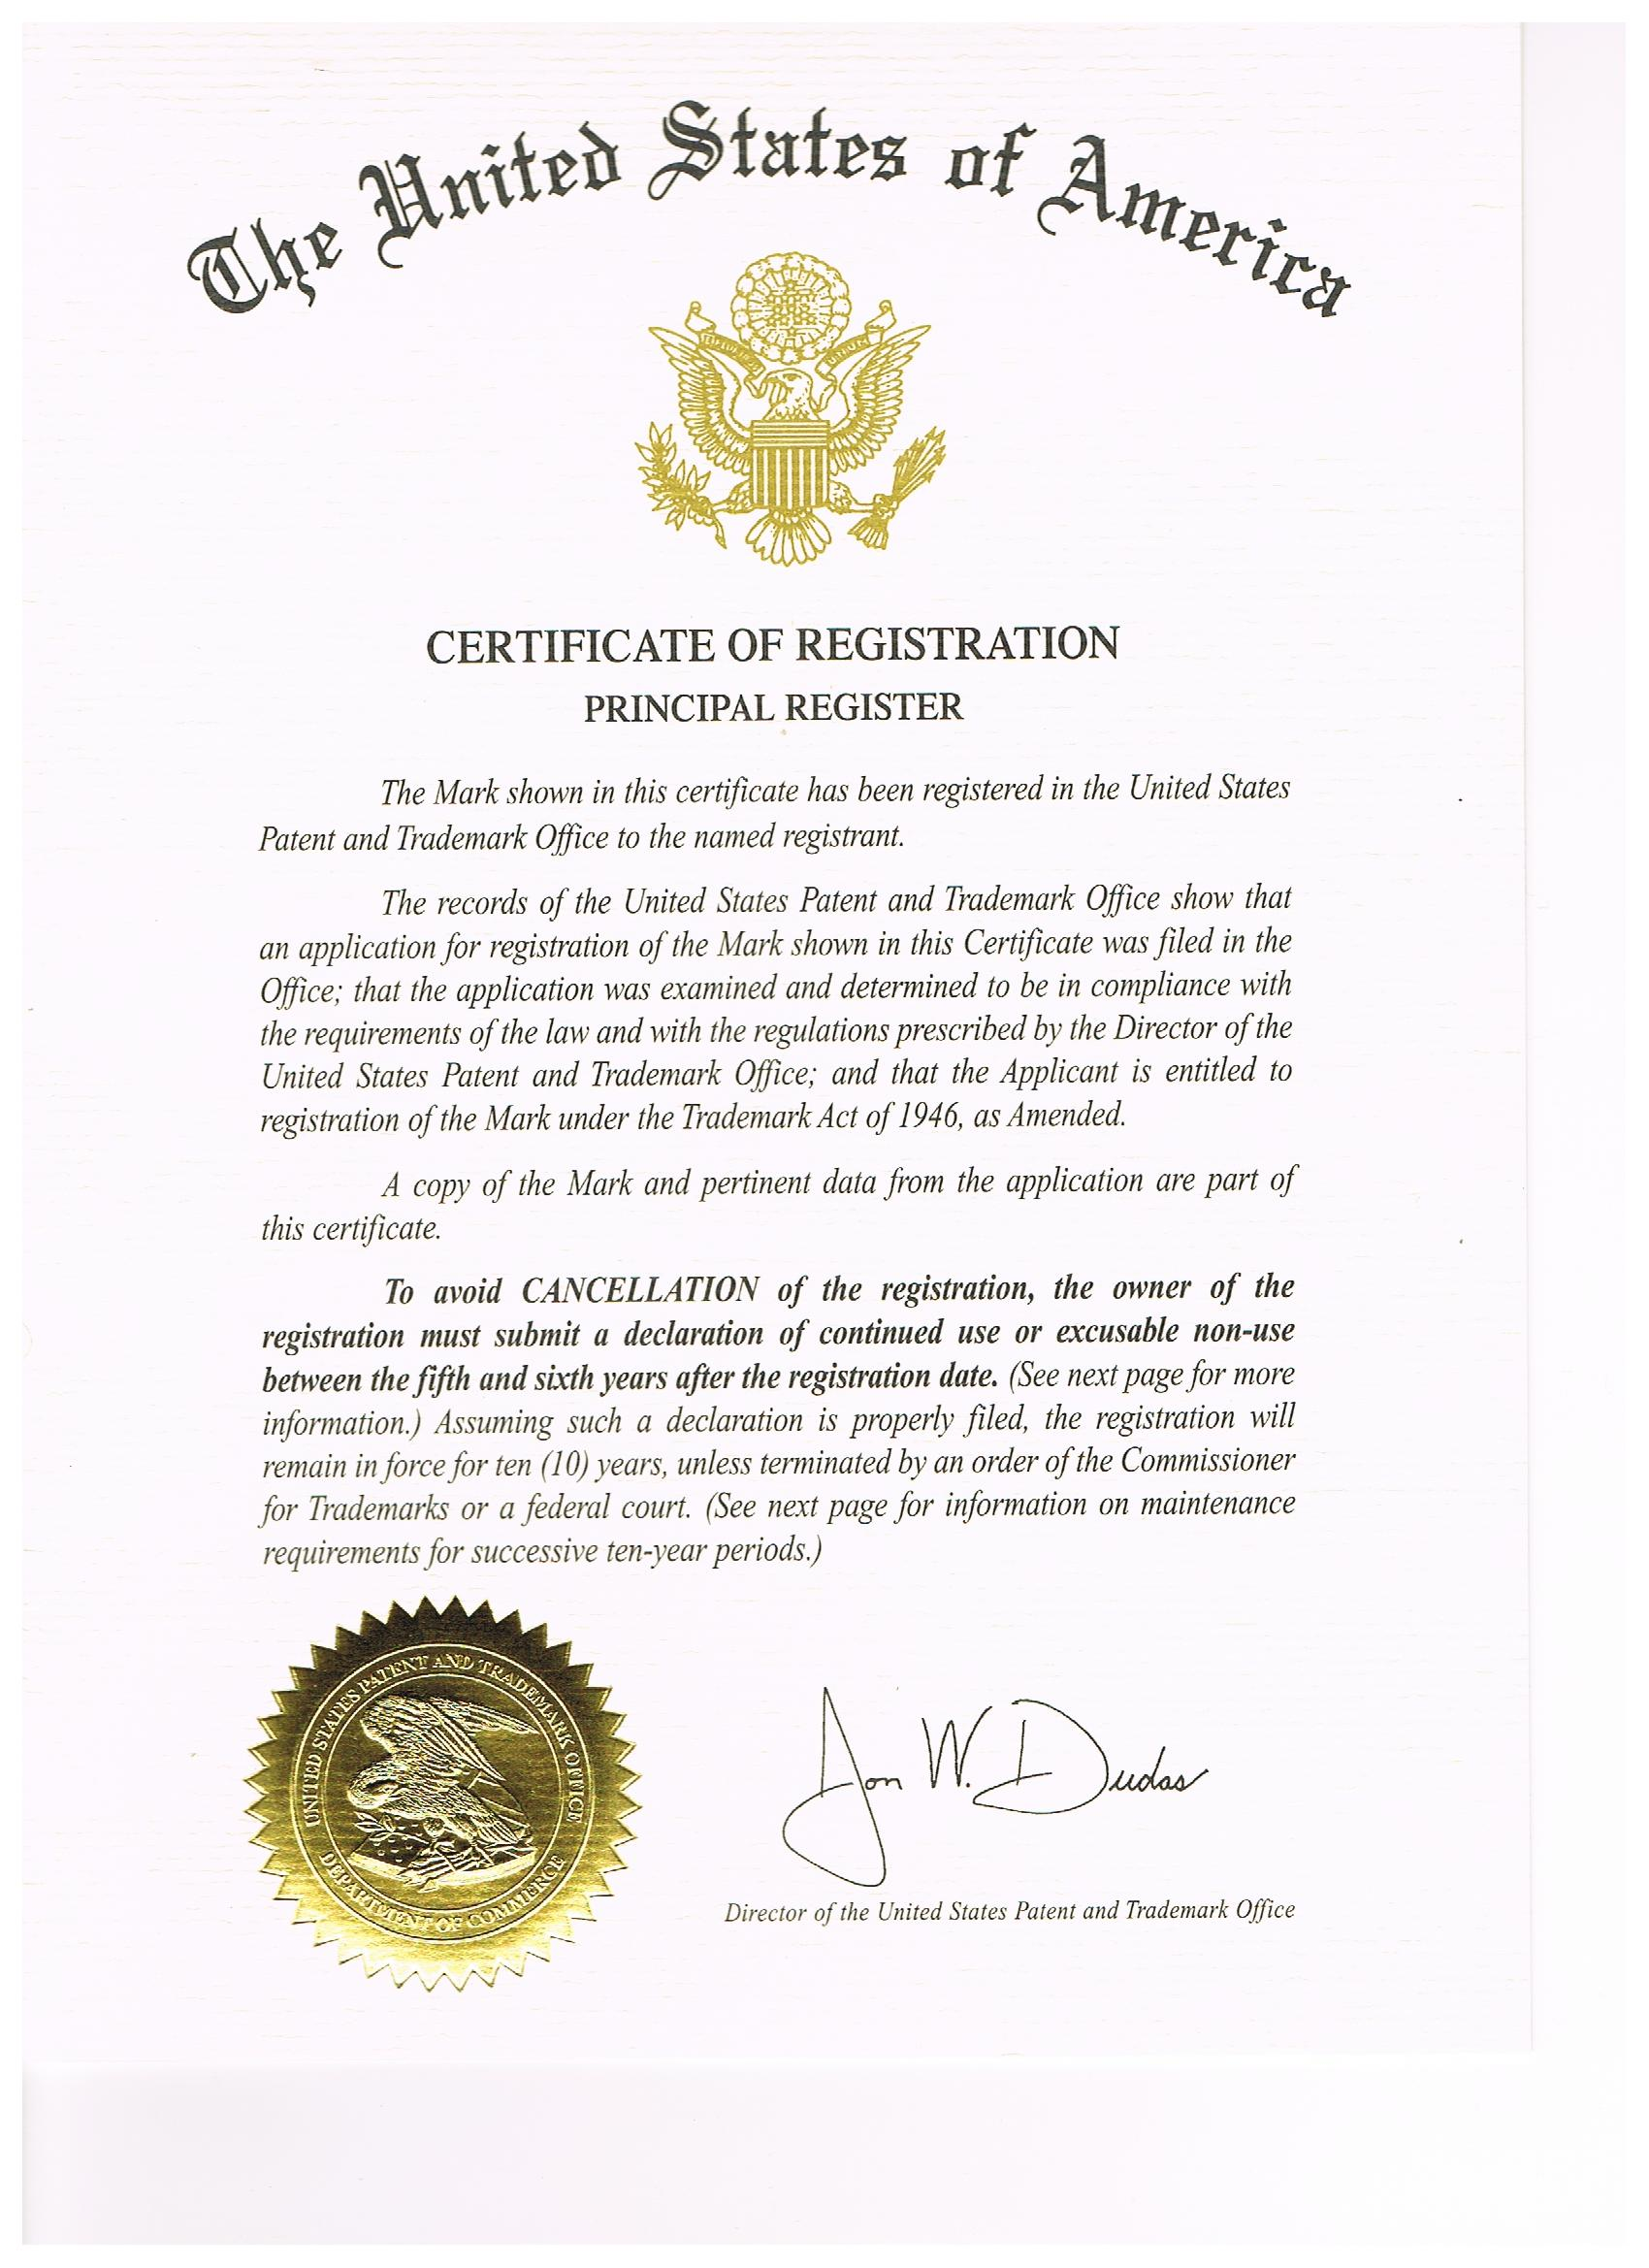
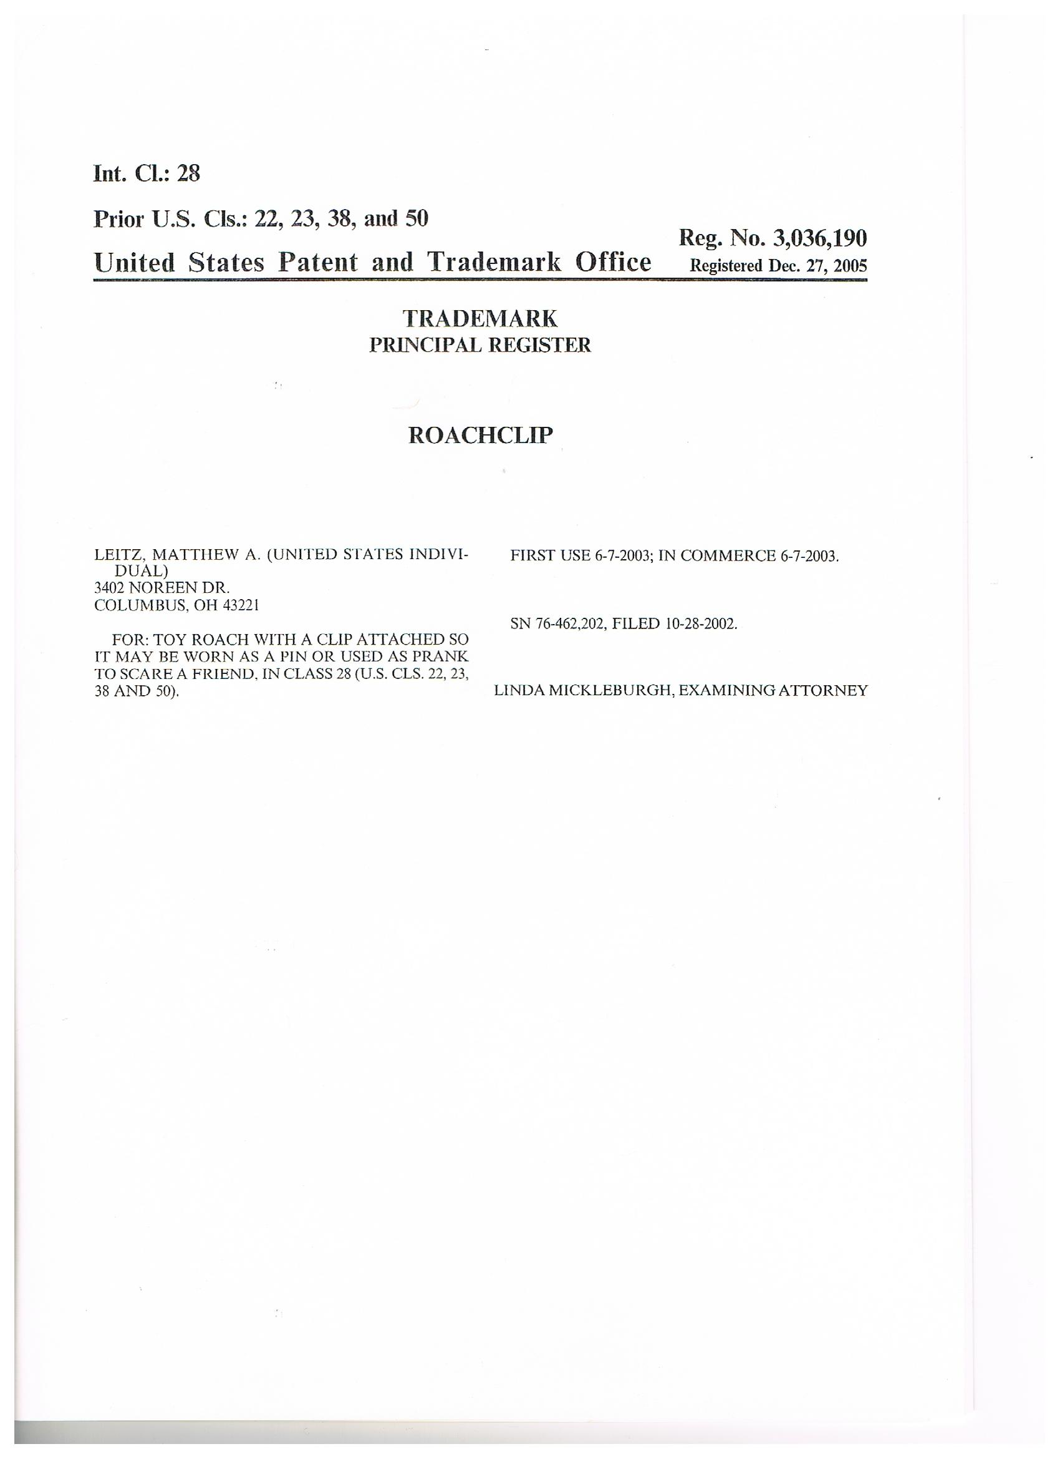
2. Products Not Paraphernalia

2A. Product is not paraphernalia as defined within §21 USC 863(d)
2B. Product not paraphernalia as further described in §21 USC 863(e)
2C. Roachclips® are NOT “Roach Clips” as defined in §21 USC 863(d)(5)

2A. Product is not paraphernalia as defined within §21 USC 863(d)

This section of U.S. Customs law states: “The term “drug paraphernalia” means any equipment, product, or material of any kind which is primarily intended or designed for use in manufacturing, compounding, converting, concealing, producing, processing, preparing, injecting, ingesting, inhaling, or otherwise introducing into the human body a controlled substance, possession of which is unlawful under this subchapter.”

The original Roachclips® are NOT at all intended or designed for use with any illegal substance. Their use is clearly stated on their packaging as well as on record with the U.S. government. It is an incorrect classification to say that they are “primarily intended” for any of the purposes listed in this definition and there is no evidence to conclude otherwise.

2B. Product not paraphernalia as further described in §21 USC 863(e)

This section of U.S. Customs law states:
(e) Matters considered in determination of what constitutes drug paraphernalia. In determining whether an item constitutes drug paraphernalia, in addition to all other logically relevant factors, the following may be considered:
(1) instructions, oral or written, provided with the item concerning its use;
(2) descriptive materials accompanying the item which explain or depict its use;
(3) national and local advertising concerning its use;
(4) the manner in which the item is displayed for sale;
(5) whether the owner, or anyone in control of the item, is a legitimate supplier of like or related items to the community, such as a licensed distributor or dealer of tobacco products;
(6) direct or circumstantial evidence of the ratio of sales of the item(s) to the total sales of the business enterprise;
(7) the existence and scope of legitimate uses of the item in the community; and
(8) expert testimony concerning its use.

In response to each of these items:

The only written instructions provided are on the packaging and they are as follows:

- Use them as decorations
- Wear them as fun pins
- Use them as clips for chips
- Use them to scare a friend

This addresses several of these concerns including (1) and (2) as well as (4) regarding the manner in which the product is displayed for sale. To date we have done no advertising per (3) and these items in fact will serve as advertising, many of which will be given away for free. This is why they bare our company’s website logo on the back (Roachclip.com).
In regard to (5) and (7), the Roachclips® are only sold to legitimate businesses, none of which sell any illegal items. In fact, we are in discussion with a nationally recognized chain and have hopes to have them distributed in several well respected shops nationwide once we are able to retrieve our property. This is the reason for having the product manufactured overseas, with this shipment of 20,000 pieces being our first large order to begin to fill this potential demand.

In regard to (6), while our company is in its early stages, the Roachclips® purpose is to help us with promotion of our website Roachclip.com. The website will sell items such as clothing, hand crafted goods and original art. We hope that sales of Roachclip® will be a small fraction of our overall sales and there will be absolutely NOTHING illegal sold on our website.
Lastly, in regard to (8), the only “expert testimony” regarding the use has come from the USPTO examining attorney who gave the product approval.

2C. Roachclips® are NOT “Roach Clips” as defined in §21 USC 863(d)(5)

This section of U.S. Customs law states:
(5) roach clips: meaning objects used to hold burning material, such as a marihuana cigarette, that has become too small or too short to be held in the hand;

It is understandable why the name of the Roachclips® has caused this confusion. Obviously the names are very similar, only differentiated in written form by a space in the middle. What is of primary importance is that the trademarked word Roachclip® should not be confused with the illegal paraphernalia described here as “roach clips” not only because of the difference in the way the term is written (one word vs. two words) but the way that it is defined.

The original Roachclips® are not designed to “hold burning materials” and in no way does any feature, packaging, advertising, etc imply this use. In fact, one would be highly advised not to put anything hot near the Roachclips® as they are made with a rubber material that is likely the worst type of material imaginable for holding anything hot, especially if one was going to smoke any sort of cigarette. Our product is not intended for such use and is clearly not designed as such.

It should also be noted that the Roachclip® is simply 2 commonly sold items combined together: a toy bug (cockroach) and a metal clip. Our toy cockroaches are similar in design to those sold in novelty shops around the country. The metal clip used were modeled after ones used for nametag badges. Neither of these items are intended for illegal use separately or when combined together, which is why the Roachclip® was approved by the USPTO.

Again, the official registered use for the Roachclips® with the USPTO is a “Toy roach with a clip attached so it may be worn as a pin or used as prank to scare a friend.”

3. Wrongful Seizure

3A. Product does not violate any of the terms within §19 USC 1595a(c)
3B. Product is it contraband as defined within Section 80302
3C. Important details were accidentally omitted by Customs Agent

3A. Product does not violate any of the terms within §19 USC 1595a(c)

This section of U.S. Customs law states:
(c) Merchandise introduced contrary to law
Merchandise which is introduced or attempted to be introduced into the United States contrary to law shall be treated as follows:
(1) The merchandise shall be seized and forfeited if it—
(A) is stolen, smuggled, or clandestinely imported or introduced;
(B) is a controlled substance, as defined in the Controlled Substances Act (21 U.S.C. 801 et seq.), and is not imported in accordance with applicable law;
(C) is a contraband article, as defined in section 80302 of title 49; or
(D) is a plastic explosive, as defined in section 841 (q) of title 18, which does not contain a detection agent, as defined in section 841(p) of such title.

The seized property is not “contrary to law” and it does not fall into any of the described categories and therefore should not have been seized. The Roachclips® were not stolen (A), they are clearly not a controlled substance (B), they are not contraband as described within 80302 (C), and they are not any form of explosive (D).

3B. Product is not contraband as defined within Section 80302

This section of U.S. Customs law states:
(a) Definition.— In this section, “contraband” means—
(1) a narcotic drug (as defined in section 102 of the Comprehensive Drug Abuse Prevention and Control Act of 1970 (21 U.S.C. 802)), including marihuana (as defined in section 102 of that Act (21 U.S.C. 802)), that—
(A) is possessed with intent to sell or offer for sale in violation of the laws and regulations of the United States;
(B) is acquired, possessed, sold, transferred, or offered for sale in violation of those laws;
(C) is acquired by theft, robbery, or burglary and transported—
(i) in the District of Columbia or a territory or possession of the United States; or
(ii) from a place in a State, the District of Columbia, or a territory or possession of the United States, to a place in another State, the District of Columbia, or a territory or possession; or
D) does not bear tax-paid internal revenue stamps required by those laws or regulations;
(2) a firearm involved in a violation of chapter 53 of the Internal Revenue Code of 1986 (26 U.S.C. 5801 et seq.);
(3) a forged, altered, or counterfeit—
(A) coin or an obligation or other security of the United States Government (as defined in section 8 of title 18); or
(B) coin, obligation, or other security of the government of a foreign country;
(4) material or equipment used, or intended to be used, in making a coin, obligation, or other security referred to in clause (3) of this subsection;
(5) a cigarette involved in a violation of chapter 114 of title 18 or a regulation prescribed under chapter 114; or
(6)
(A) a counterfeit label for a phonorecord, copy of a computer program or computer program documentation or packaging, or copy of a motion picture or other audiovisual work (as defined in section 2318 of title 18);
(B) a phonorecord or copy in violation of section 2319 of title 18;
(C) a fixation of a sound recording or music video of a live musical performance in violation of section 2319A of title 18; or
(D) any good bearing a counterfeit mark (as defined in section 2320 of title 18).
(b) Prohibitions.— A person may not—
(1) transport contraband in an aircraft, vehicle, or vessel;
(2) conceal or possess contraband on an aircraft, vehicle, or vessel; or
(3) use an aircraft, vehicle, or vessel to facilitate the transportation, concealment, receipt, possession, purchase, sale, exchange, or giving away of contraband.

Rather than replying to each of these items individually, I will respond primarily to section (1) as certainly none of the other sections would be in question as they refer to items including firearms, counterfeit coins, tobacco cigarettes, computer programs, music recordings and aircrafts.
Section 1 refers to “narcotic drugs” which clearly would not include the Roachclips® as they are not drugs in any way, shape or form. The referenced definition in “ The Comprehensive Drug Abuse Prevention and Control Act of 1970” defines illegal consumable substances, which would not incorporate the Roachclips® as they are clearly not consumable. Furthermore, the Section 80302 refers to an “intent to sell or offer for sale in violation of the laws and regulations of the United States” which is not at all the case with the wrongly seized products.

3C. Important details were accidentally omitted by Customs Agent
It was requested of the licensed customs agent we hired to provide information including details of our USPTO approval. This information would have likely saved both your office and ours the effort of this petition process. If you would like to reach our customs agent her name is Natalia Teja, her Direct Line is 619-661-6784 and her email is natalia@ferrerbrokers.com.
4. Product Approved for Commerce
4A. Verified statement previously registered (per § 2.33 of USPTO Rules of Practice)
4B. Proof of use in commerce requested and provided (per examining attorney)
4C. Roachclips are sold legally for registered use at legitimate businesses
4A. Verified statement previously registered (§ 2.33 of USPTO Rules of Practice)
As a part of the U.S. Trademark application process it was required that we provided a “verified statement of use”. In order to comply with this verification we had to show “that the mark is used in commerce” as defined within USPTO Rules of Practice § 2.33. This verification was provided and the application was approved per the U.S. examining attorney.
The date stamped on the Goods and Services mark for first official use commerce is as published by the U.S. Patent and Trademark office is 6/7/2003. (Reference IC 028. US 022 023 038 050)
4B. Proof of use in commerce requested and provided (per examining attorney)
As part of the Trademark application it was requested that we prove the product was used in commerce. This proof was provided and we had no issue as to any form incompliance with federal or state law. If Roachclips® were intended for any form of illegal activity than the application would have been denied per Federal Statute § 2.69. The approval of the application effectively verifies the product for use in U.S. commerce, specifically with the registered use of simply being a “toy roach with a clip attached so it may be worn as a pin or used as prank to scare a friend.” The product has no illegal intended use and has never been sold as such.
4C. Roachclips are sold legally for registered use at legitimate businesses
Roachclips® have been sold in legitimate businesses in several states within the United States. We have never encountered any form of legal challenge in selling the product and to our knowledge there has never been any use by consumers that does not fall within its federally registered intended use of being “worn as a pin or used as a prank to scare a friend.” As mentioned earlier there are several well respected “house hold” name businesses who we hope to carry the product once we are able to gain relieve from this wrongful seizure.

5. Exempt as per Federal Office
5A. If products were incorrectly categorized still would be exempt per §21 USC 863(f)

5B. Supported by USPTO Federal Statute § 2.69
5C. You Have Ability to Overturn Seizure per 19 USC 1618

5A. If products were incorrectly categorized still would be exempt per §21 USC 863(f)

As described in detail within this petition, the seized Roachclips® are NOT paraphernalia and should not be treated as such. That said, the case for overturning this wrongful seizure is further supported by Customs Law §21 USC 863(f). This section refers to exemptions on the ruling used to wrongfully classify the product.

This section of U.S. Customs law states:

(f) Exemptions
This section shall not apply to—
(1) any person authorized by local, State, or Federal law to manufacture, possess, or distribute such items;

Again, this point is not made to imply that the Roachclips® are at all paraphernalia per 21 USC 863 as they are clearly NOT as described within this petition. This point is simply made to further the argument that the previous approval of this product for use in commerce by another Federal agency is strong enough to have our property released, even if the initial categorization of the product by U.S. Customs was not accurate as described by the extensive arguments made in this petition.

5B. Supported by USPTO Federal Statute § 2.69
When our Trademark was approved by the USPTO it was subject to review of compliance with other laws as per § 2.69 of their Federal Statutes. According to this section they strive to ensure compliance in regard to the “sale or transportation of any product for which registration of a trademark is sought is regulated under any Act of Congress… for the purpose of determining lawfulness of the commerce…”
Simply put, there is nothing illegal about toy cockroaches with clips attached. While it is understood why there was confusion on this given the name of the product, after reviewing this petition we hope your further understanding of the product and its intended use will help you to come to the same conclusion of the U.S. Patent and Trademark Office.
5C. You Have Ability to Overturn the Seizure per 19 USC 1618
As per 19 USC 1618 it is our hopes that you will agree that our “forfeiture was incurred without willful negligence or without any intention on the part of the petitioner to defraud the revenue or to violate the law.” The products are not only intended for no illegal purposes, but as described they have been approved for legal commerce by a federal agency. With these combined factors we hope you can “find the existence of such mitigating circumstances as to justify the remission” of our products.
We truly appreciate the time you have taken read the details of this petition. While the property may seem relatively small in value as compared to many cases you review, to us it is very large. These items are not only our flagship product, but also serve as our website’s advertising. Our company not only hopes to provide employment for a growing staff, but our website strives to offer artists and independent business owners a place to sell their unique and handcrafted goods. Having our products released will be a large relief and will allow us to move forward conducting business.
Thanks again and please do not hesitate to contact me if I can further clarify anything or provide additional information.

